Music Jam Session
Are you over the age of 60? Do you play an instrument or sing? Have you been looking
for an opportunity to get together with other musicians and jam on your favorite tunes? If you answered yes to these questions then we have the jam session for you.

WHEN
Monday:
May 1, 15, 22
June 5, 26
4:30 p.m.–6:30 p.m.

WHERE
Cambridge Senior Center 806 Massachusetts Avenue
The Cambridge Senior Center and the Cambridge Public Health Department are presenting a music jam session series this spring on select Mondays beginning at 4:30 p.m.
Saxophonist Bobby Tynes will once again host the sessions with his group of amazing musicians who will provide the rhythm section of your dreams. You will enjoy making music with these musicians. Their music inspires all to keep coming back for more!

So, bring your voice, drumsticks, guitar, percussion, your horns, harmonicas and most importantly your love of playing music with others.

No registration required to attend.

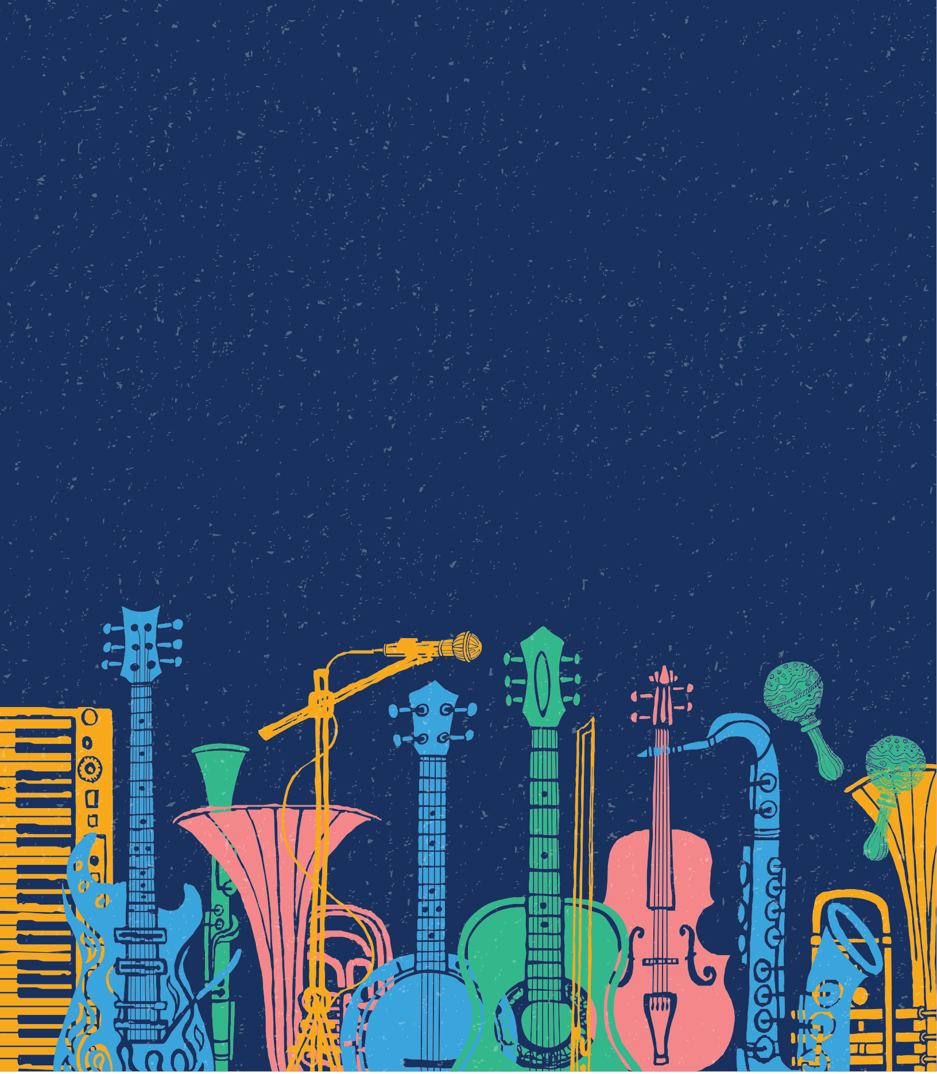

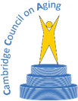
This event is supported by funding through the Cambridge Arts Council, the Massachusetts Cultural Council and the Cambridge Council on Aging.

